לחזור על המילים הבאות:

son - בן

daughter – בת

niece - אחיינית

nephew - אחיין

cousin – בן דוד \ בת דודה

קיראו את המשפטים. כיתבו רק את השמות במחברת. (אל תשכחו שיש תמיד אות גדולה בהתחלת שם.)



1. Tim has a pet cat. 3. Anna has a pet dog.

Tim’s pet cat is fat. Anna’s dog is fat.

Tim’s cat is Mitsi. Anna’s dog is Spot.

1. Ben has a pet cat. 4. Rob has a pet dog.

Ben’s cat is not fat. Rob’s dog is not fat.

Ben’s pet cat is Bambi. Rob’s dog is sad.

Rob’s dog is Tops.

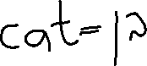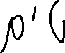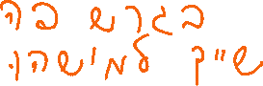

קיראו את המילים וכיתבו במחברת.



1. kit 4. ken 7. kid 10. keg
2. link 5. clock 8. neck 11. pink
3. bonk 6. honk 9. desk 12. trek



קיראו וסימנו **✓** או **X**

**Kim**

Kim is a kid.

Kim has 2 pets.

Kim has a pet cat.

Kim’s cat is black.

Kim has a pet dog.

Kim’s dog is fat.

Mick is a man.

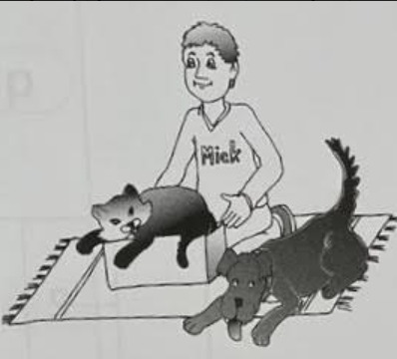

Mick has a cat and a dog.

Mick’s cat is fat. It is in a box.

His dog is big and black.

Mick and his dog sit on a mat.

Yes No

1. Kim has 3 pets.  
2. Kim has a pet cat.  
3. Mick is not a man.  
4. Mick has a cat and a dog.  

קיראו וסימנו **✓** או **X**

Anna has a pet dog.

Anna’s dog is Spot.

Spot can stand on a box.

Spot can sit.

Tim has a robot.

Tim’s Robot is Rick.

Rick can stand.

Rick can kick.

Sam has a pet cat.

Sam’s cat is Mitsi.

Mitsi is a fat, black cat.

Mitsi has a rat.

Yes No

1. Spot can sit.  
2. Tim has a dog.  
3. Mitsi is a fat, black cat.  
4. Mitsi has a robot.  

קיראו את המילים וכיתבו במחברת.



1. but 3. fun 5. us 7. hut
2. mud 4. bus 6. sun 8. nut