22 September 2024 9 שיעור

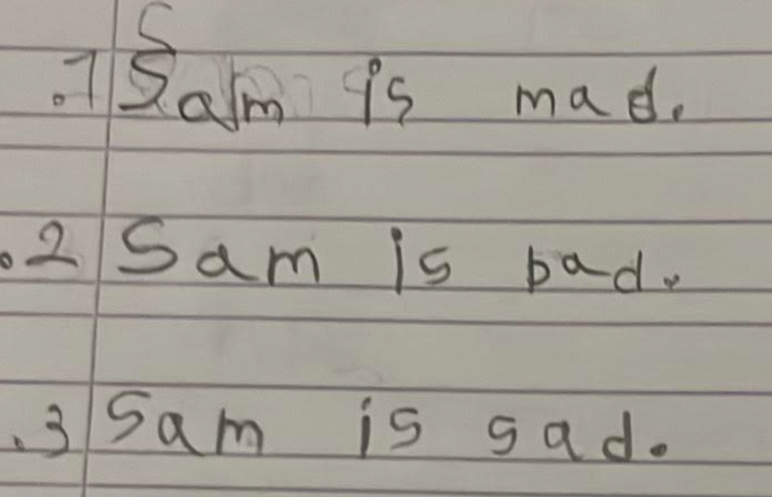



F f

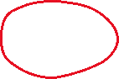

What is the name of the letter? What sound does the letter make?

What words do you know that start with this letter?

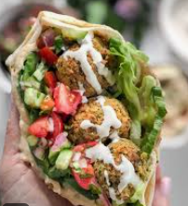 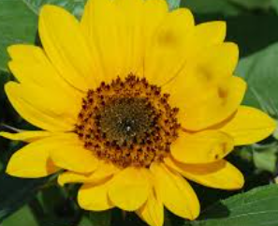



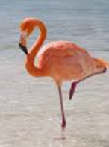



C c



What is the name of the letter? What sound does the letter make?

What words do you know that start with this letter?

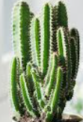



קיראו את המילים וכיתבו במחברת.



1. fat 2. cat 3. cam 4. bid 5. fit



1. it 7. cab 8. had 9. fan 10. mid



11. cad 12. can 13. hint 14. add



קיראו את המשפטים.

1. Mitsi is a cat.



1. Mitsi is a fat cat.



1. Mitsi is a sad cat.



1. Mitsi is a fat, sad cat.

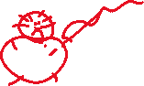

25 September 2024 10 שיעור

O o



What is the name of the letter? What sound does the letter make?

What words do you know that start with this letter?

קיראו את הפסוקיות וכיתבו במחברת.

1. hot 2. on 3. sob 4. son
2. con 6. hob 7. cot 8. not

הקיפו את המילה המתחרזת עם המילה הראשונה בכל שורה.

1. hot hat cot hit mob
2. sit sat him bin hit
3. man bad fat mad fan
4. cod cot hot cad mod

הקשיבו וסמנו a, i או o.

1. h___t 2. h___t 3. h___t 4. m___n

1. b___d 6. b___d 7. c___t 8. c___t
2. d___t 10. n___t 11. n___t 12. h___m

קיראו את המשפטים.

1. It is a man. It is not a cat.
2. It is a mat. It is not a bin.
3. It is a hat. It is not a cot.

X x



What is the name of the letter? What sound does the letter make?

What word do you know that has this letter?

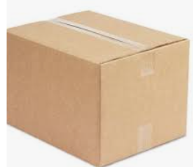 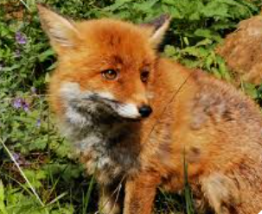 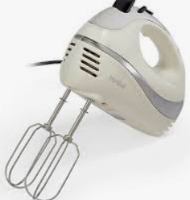

קיראו את המילים וכיתבו במחברת.

1. six 2. fan 3. box 4. fat

1. fox 6. mix 7. fib 8. fix

קיראו את הפסוקיות.

1. a fox in a hat
2. a fox on a mat
3. a fox on a hat
4. an ant on a box
5. an ant on a fox
6. an ant in a box
7. a man in a bin
8. a mat in a bin
9. a man on a bin